**1. Product Overview**

The **WIN-SN-TNH-M Sensor Board** is a **high-precision environmental sensing solution** designed for industrial, commercial, and residential applications. It enables **accurate measurement of environmental parameters**, including **temperature, humidity**.

Equipped with **advanced sensor technology** (detailed in Table 1 and Table 2), the board ensures **reliable and precise data acquisition**, making it ideal for **air quality monitoring, climate control systems, and environmental assessment applications.**

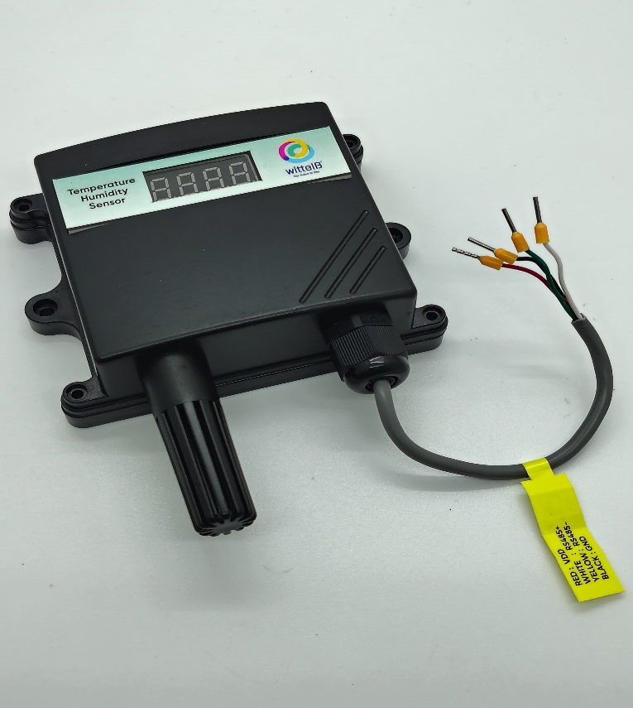The **WIN-SN-TNH-M** supports **Modbus RTU (RS485) communication**, allowing seamless integration with industrial automation systems, data loggers, and IoT platforms. Its **low power consumption** and **wide operating temperature range** make it suitable for deployment in both **indoor and outdoor environments**.

In addition to Modbus RTU output, **the device features real-time sensor data display on a 7-segment display,** which is especially useful for monitoring and troubleshooting issues on-site. The sensor board can be powered by a DC power supply, making it a practical solution for a wide range of applications.

**Table 1**

|  |  |  |  |  |
| --- | --- | --- | --- | --- |
| Sensor Name | Temperature Measuring Range | Humidity Measuring range | Operating Temperature | Measuring Accuracy |
| AHT20 | **-40°C ~ 85°C.** | **0~80% RH.** | **-40°C ~ 85°C.** | **0.3°C, 2.0 %RH** |

**2. Precautions**

1. Read all instructions before using the sensor board.
2. Keep the sensor board away from water and moisture to prevent damage.
3. Do not disassemble or modify the sensor board.
4. Use only the specified power sources and mentioned.

**3. Power Supply Connection**

* **DC Connection**

1. Use 12-24V@ 1A, Power supply.
2. Don’t make loose connection.

**4. Configuration Settings**

* Communication Speed 9600 – 115200 Kbps (Software setting)
* Data Bits 8
* Parity None
* CRC Yes
* Slave ID Software setting(1-247)
* Function Code 0X03 (Read Holding Register)

|  |  |  |  |  |  |
| --- | --- | --- | --- | --- | --- |
| ID | Function  Description | Register  Description | Modbus Function Code | Protocol | Data  Type |
| 1 | **Display Baud Rate (Default: 960)** | **40010** | **0x03** | **RS485** | **16-bit int** |
| 2 | **Enter New Baud Rate** | **40011** | **0x03** | **RS485** | **16-bit int** |
| 3 | **Display Slave ID (Default: 1)** | **40012** | **0x03** | **RS485** | **16-bit int** |
| 4 | **Enter New Slave ID** | **40013** | **0x03** | **RS485** | **16-bit int** |
| 5 | **Display Parity (Default: None-3 And for Odd-1, Even-2)** | **40014** | **0x03** | **RS485** | **16-bit int** |
| 6 | **Enter New Parity** | **40015** | **0x03** | **RS485** | **16-bit int** |
| 7 | **Display Stop Bit (start-2/stop bit-1)** | **40016** | **0x03** | **RS485** | **16-bit int** |
| 8 | **Enter New Start/ Stop Bit** | **40017** | **0x03** | **RS485** | **16-bit int** |

**5. Modbus RS485 Data Storage register**

|  |  |  |  |  |  |
| --- | --- | --- | --- | --- | --- |
| ID | Function Description | Register Description | Modbus Function Code | Protocol | Data Type |
| 1 | **Temperature** | **40000** | **0x03** | **RS485** | **16-bit int** |
| 2 | **Humidity** | **40001** | **0x03** | **RS485** | **16-bit int** |
| 3 | **TVOC** | **40002** | **0x03** | **RS485** | **16-bit int** |
| 4 | **Barometric Pressure** | **40003** | **0x03** | **RS485** | **16-bit int** |
| 5 | **IAQ** | **40004** | **0x03** | **RS485** | **16-bit int** |
| 6 | **CO2** | **40005** | **0x03** | **Rs485** | **16-bit int** |

**Important Note:**

1. If you want to enter the baud rate 9600/19200/38400/57600/115200etc, enter it like this 960/1920/3840/5760/11520etc.
2. After that press the reset button or reboot the system.
3. Then you will get the present value of 11520 at 40010 baud rate (115200) and 2 at 40012 slave id.
4. **Temperature and Humidity Data are provided in the multiple of 10, for the sack of higher resolution, you need to divide it by 10 to obtain the actual reading. Example. Temperature 345/10 = 34.5 °C and Humidity 377/10 = 37.7%**

**6. Modbus Configuration**

Here is an example of receiving data on Mb poll software.

* Open Mb-poll software connect using configuration setting (Default baud rate is 9600 and slave id is 1).
* After connecting you will get data as shown below

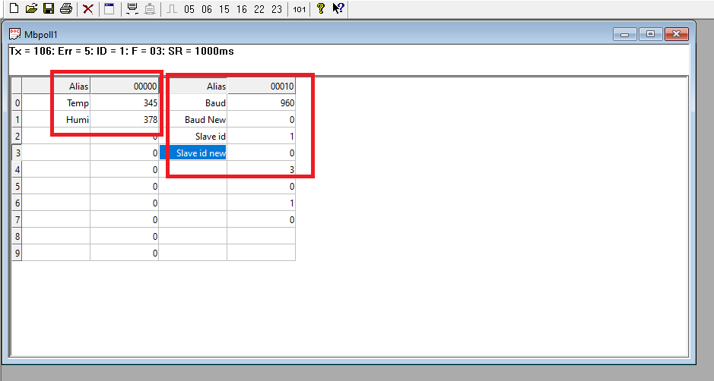

* As you can see in the image above, the resistor 40010 – 960 represents the present bund rate (9600) of the board and 40012 – 1 represents the present slave id of the board.
* To change the baud rate and slave id you must enter a value on the 40011 resistors for the baud rate and 40013 for the slave id as shown in the image below.
* Now you can see data. In below image set 115200 baud rate and slave ID 2.

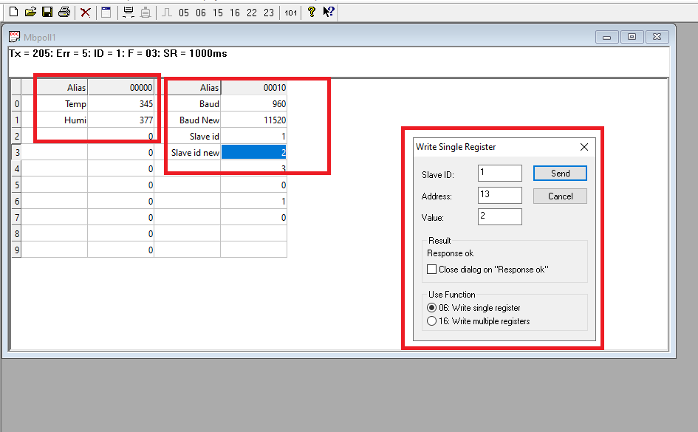

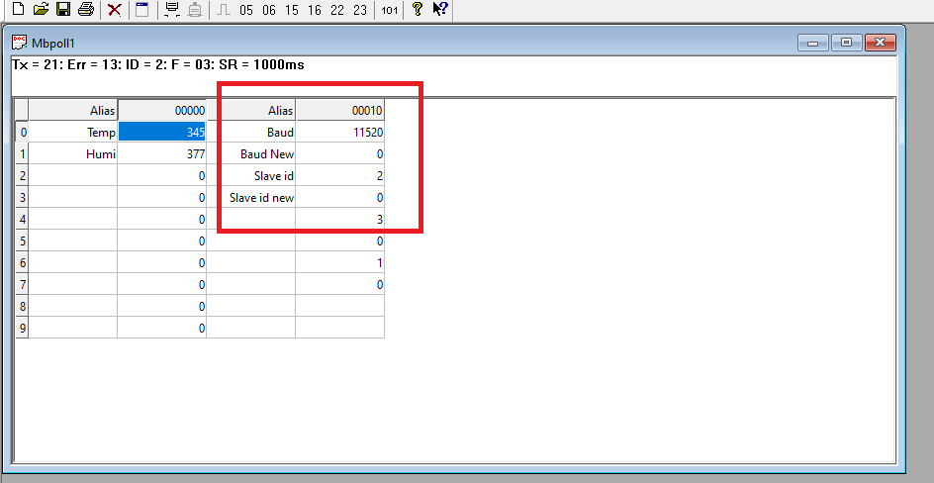

**Hard reset Setting**

Somehow you forgot the baud rate or slave id of the board then remove the jumper (as shown in the image) from the board reboot the system or press the reset button (given on the board). Then you will get the default baud rate of 9600 and slave id 1.

**Contact Information**

**Augmatic Technologies Pvt. Ltd.**

**Plot no 6, Shah Industrial Estate II,**

**Kotambi, Vadodara – 391510.**

**Email – Sales@wittelb.com**